Muscle Rupture (Strain)

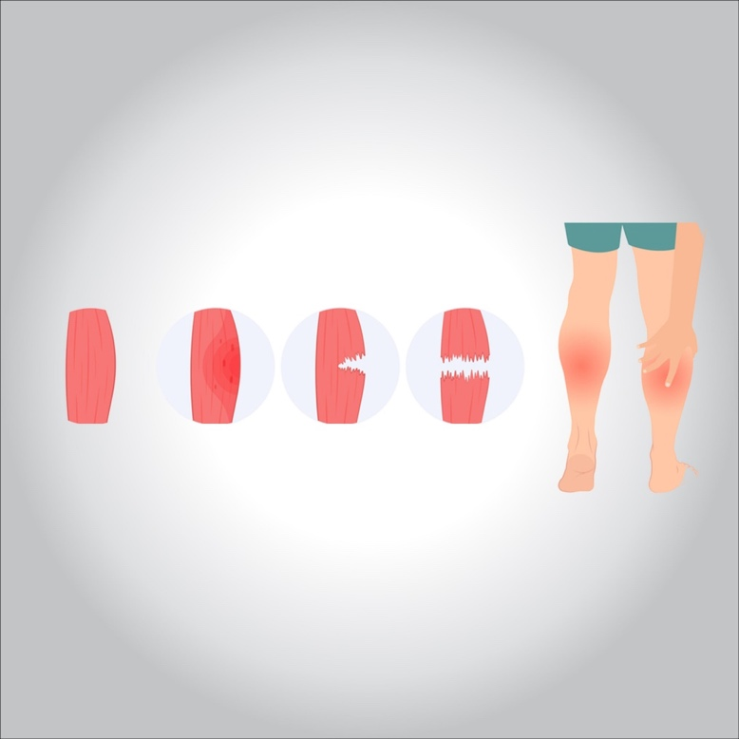

**It is a rupture of the cyst encapsulated in the muscles, muscle fibers, or tendons as a result of intense, sudden and severe muscle exertion to a greater degree than the muscle’s ability to endure this passive.**

**Symptoms of muscle rupture:**

* **The pain of the place of injury**
* **Hearing a sound (crackle in the affected muscle)**
* **Swelling and hematoma, as a result of internal bleeding**
* **The inability of the affected muscle to function and the severity of the sensitivity**
* **The hematoma is evident around the site of the injury 48 hours after the injury**
* **In severe cases, the tumor lasts 72 hours after infection**
* **The high temperature of the affected part**
* **Change the skin color from natural redness to blue to yellow**

**Treatment:**

1. **Preventing the player from continuing to play with the injured member taking the best comfort positions**
2. **The complete rest of the player physically and psychologically to avoid a shock to the player, while not moving the injured part**
3. **The cooling compress continues to work within 48: 72 hours, at a rate of 4: 5 times a day**
4. **Make a suitable compression band around the place of injury**
5. **You must have complete control of bleeding and internal spillage by the necessity not to use the muscle and to rest completely**
6. **Placing the affected muscle or muscles in a fully relaxed position to reduce tension or contractions**
7. **Negative comfort for the affected member according to the severity and degree of injury**
8. **Raise the affected area above the heart to reduce blood flow to the affected area**
9. **Avoid using all kinds of heat or massages throughout the acute period of injury to prevent further bleeding**